Buzzer

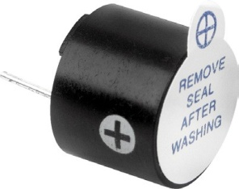

# https://m.media-amazon.com/images/I/21eVi5BGyZL.jpg

# Specifications:

Rated Voltage : 6V DC

# Features

* Black in colour
* With internal drive circuit
* Sealed structure
* Wave solderable and washable
* Housing material: Noryl

# Applications

* Computer and peripherals
* Communications equipment
* Portable equipment
* Automobile electronics
* POS system
* Electronic cash register

Operating Voltage : 4 to 8V DC

Rated Current* : ≤30mA Sound Output at 10cm* : ≥85dB Resonant Frequency : 2300 ±300Hz Tone : Continuous

Operating Temperature : -25°C to +80°C Storage Temperature : -30°C to +85°C Weight : 2g

*Value applying at rated voltage (DC)

# Diagram



Dimensions : Millimetres Tolerance : ±0.5mm

